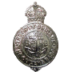
The Boys' Brigade Awards
The Queen’s Badge
Tick each box as you receive the respective award or level.
All □ boxes ticked you qualify for Sir William Smith award.
All □ boxes ticked you qualify for Queen’s Badge.
One Year Silver Service Awards |  |  |  |  |  | Leadership Courses
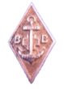    | 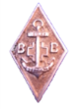 |  |  |  |  | 2day leadership 1box    
BB Knowledge Awards
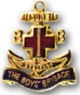  Six Months    |  | Pre Certificate |  |  | Certificate | 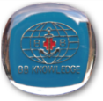  BB Knowledge
Core Group Badges All 8 boxes in the Core Group must be ticked
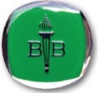  Citizenship    |  |  |  | 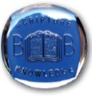  Scripture Knowledge     |  | 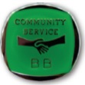  Community Service    
Skill Badges |  |  |  |  |  |  | An additional 5 levels from any activity award.
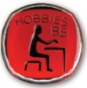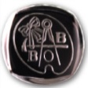 |  |  | Skills or Hobbies.     
Outdoor Adventure Badges
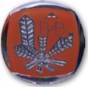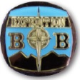 |  |  | Environment or Expedition.     
Physical Badges
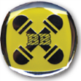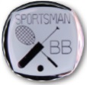 |  |  | Physical or Sportsman.     

